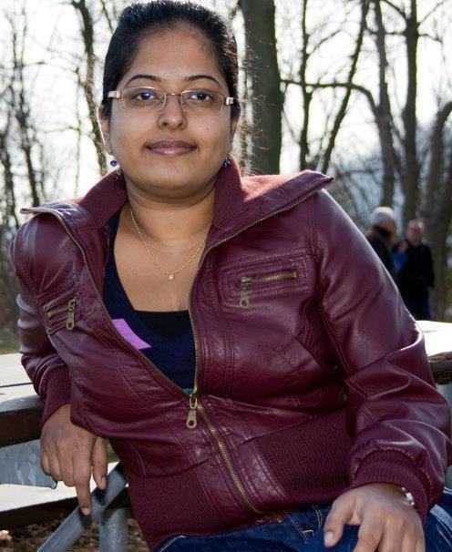
Welcome Karthiga!
There has been a new addition to the Communications Team – Karthiga Prasanna has joined us in the role of Social Media Champ, taking over from another wonderful volunteer Chintan Shah.
Karthiga will keep you all connected, engaged and informed about what’s happening at the chapter through Twitter, Facebook and our LinkedIn Group.
Join and follow us on social media today!
<<INSERT THE CONNECT WITH US GRAPHIC WITH THE SOCIAL MEDIA ICONS HERE>>

And, a special thank you to Chintan Shah who has been leading our social media engagements for the past 18months. During this time, our Twitter followers have doubled and our LinkedIn Group has become equally popular with a number of interesting discussions taking place. Chintan will remain in a key volunteer role at the Chapter, working on the Mentoring Program. Thank you, Chintan!

